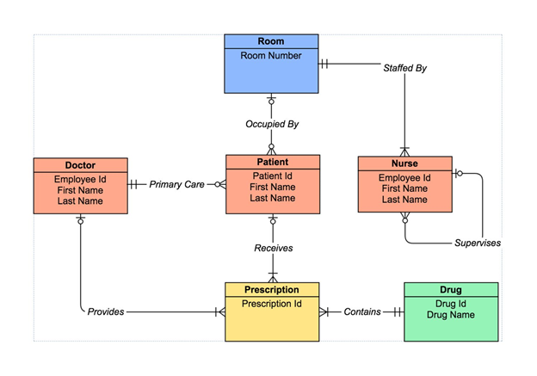

Room (**Roomno**)

* Each room is staffed by nurse and the number of nurses in a single room can be one or more. The relationship between Room entity and Nurse entity is one to many.
* Each room is occupied by patient and the number of patients in a single room can be zero or more. The relationship between Room entity and Patient entity is one to many.

Doctor (**Employeeid**, Firstname, Lastname)

* The doctor is the primary care of patient and the number of patients cared by one doctor can be zero or more. The relationship between Doctor entity and Patient entity is one to many.
* The doctor is the provider of treatment prescription and can give one or more prescription to the patient. The relationship between Doctor entity and Prescription entity is one to many.

Patient (**Patinetid**, Firstname, Lastname, *Roomno, Employeeid*)

* Each patient is cared by one doctor only. The relationship between Patient entity and Doctor entity is many to one.
* Each patient is stand in zero or one room. The relationship between Patient entity and Room entity is many to one.
* Each patient is receiving zero or more prescription. The relationship between Patient entity and Prescription entity is one to many.

Nurse (**Employeeid**, Firstname, Lastname, Supervisorid, *Roomno*)

* Each nurse can be supervising for zero or more nurse. The Nurse entity have one to many (self-relations).
* Each nurse can be in one room only. The relationship between Nurse entity and Room entity is many to one.

Prescription (**Prescriptionid**, *Employeeid, Patientid, Drugid*)

* Each prescription is provided by one doctor only. The relationship between Prescription entity and Doctor entity is many to one.
* Each prescription is given to one patient only. The relationship between Prescription entity and Patient entity is many to one.
* Each prescription contains one drug only. The relationship between Prescription entity and Drug entity is many to one.

Drug (**Drugid**, Drugname)

* Each drug can be in one or more prescription. The relationship between Drug entity and Drug Prescription is one to many.

Replay:

Good work. However, you can give little more explanation as an introduction before starting the entities..  This diagram explains about the Hospital Management System….like this …..points can be added..

               Write primary and foreign key separately

Add Admin Manager:

Admin manager is managing doctors, rooms and patients. Based on the relationships, identify all the attributes along with the keys.

adminmanager( mgrid, mgrname, contactno)